CONTACTING CLERGY OR JUSTICES OF THE PEACE

The Chaplaincy can provide the names and addresses of local affiliated clergy. The University Chaplain performs weddings for affiliated couples. ORDAINED, ACTIVE CLERGY AND JUSTICES OF THE PEACE ARE PERMITTED TO PERFORM WEDDINGS AT GODDARD CHAPEL AND THE INTERFAITH CENTER.

Clergy generally expect an honorarium for services provided in counseling and in officiating at weddings. The honorarium is not covered by the chapel reservation fee.

SELECTING MUSICIANS AND MUSIC

Goddard Chapel is distinguished by particularly good acoustics and houses a Hook and Hastings tracker organ, the twenty-five bell Bowen-Tilton Memorial Carillon, and a baby grand piano. All three instruments are regularly used for weddings. The Goddard Chapel Director of Music is Dr. Janet E. Hunt. She is generally available to play the three instruments for weddings. She can also provide the names of other instrumentalists and singers. She can be reached at (617) 462-6996. A couple may have musicians of their own choice, but they must give the desired musician’s name, address and phone number.

Honoraria for musicians can vary. Parties should inquire about an honorarium before actually inviting a musician to perform.

There are no instruments available at the IFC, and couples can provide their own music.

ARRANGING FOR FLOWERS

Professionally designed floral arrangements are often used to decorate for weddings. As the chapel table altar is too small for most average sized table-top arrangements, these are not suggested. In most instances, couples have ordered a large standing arrangement for the front-center section of the altar
or two arrangements, one for each side of the altar. Potted plants and bouquets of cut flowers have also served as attractive decorations for the chancel area.

HOSTING A RECEPTION

Private receptions are frequently held on campus. The university has several attractive facilities which can accommodate either large or small gatherings. The Alumnae Lounge in the Aidekman Arts Center has space for 100 to 150 guests. Additionally, 51 Winthrop Street, the former Sacred Heart Church, is now available for wedding receptions. The Campus Conference Bureau at (617) 627-3568 can be contacted for further information and campus locations.
The Cabot Intercultural Center at Tufts has three rooms which can be rented for receptions. They can accommodate up to 80 guests total. Additional information can be obtained through the Fletcher School of Law and Diplomacy at (617) 627-3085.

TAKING PICTURES

There are no set restrictions on the use of cameras in Goddard Chapel. Often, however, officiating clergy prefer to limit picture taking to times before and after the ceremony. Please consult with your officiating clergy, photographer and videographer prior to the ceremony.

CONCERNING CHAPEL ACCESS AND PARKING

Parking is usually available in the staff/employee parking areas, located off Packard Avenue or behind West, Bendetson, Packard and East Halls.

Goddard Chapel stands at the center of the academic quadrangle on the Medford campus. Its hundred foot bell tower is a distinctive landmark which is visible from all directions.

Chapel guests usually enter the campus on Packard Avenue or Professors Row.

The Chapel itself is usually accessible to automobiles for members of a bridal party, elderly or handicapped guests. Campus fire regulations, however, require that motor vehicles remain attended at all times. Parked or unattended vehicles will be ticketed and towed.

The tower door is on ground level and the office entrance has three small outdoor steps. The Sexton is available to assist elderly and handicapped guests as they enter the Chapel.

The IFC has only street parking and, therefore, is limited in that respect. There are some spaces available on Boston Avenue and/or on Emery Street.

MAKING A RESERVATION

Goddard Chapel or the IFC may be reserved for weddings either in person or by telephone (617) 627-2976. Reservations are only confirmed upon the receipt of a completed reservation form, accompanied by a full payment for the use of either space. A tentative reservation automatically lapses if it is not confirmed within one month of the original reservation request. All weddings must be scheduled at least six weeks in advance.

The cost for the use of Goddard Chapel and the IFC vary. Students, other members of the Tufts community and Tufts alumni are expected to pay a fee as specified on the reservation form. The fee must be paid by check, payable to the “Trustees of Tufts College.” Refunds are only possible when people cancel their reservation at least one month prior to this scheduled use. The charge for the use of the building contributes to its ongoing maintenance and improvement.

Reservations are made in two-hour time blocks. The hour before the wedding is reserved for floral set-up, videographer, photographer and guest arrival. The second hour is devoted to the wedding itself. Two hours in most cases is sufficient. In the event that a couple feels that more time is needed, arrangements may be made by calling the Sexton to see if the Chapel will be free at that time. For an additional fee, extra time will be granted if available.

In confirming their reservation, parties should schedule rehearsal time in the Chapel. The Chapel Sexton, who attends each function, is available to answer questions about the building and basic wedding etiquette during the office hours and at the rehearsal. Questions may also be directed to the Chapel at 617-627-3427.

SOME BASIC INFORMATION

Goddard Chapel is one of Tufts most architecturally distinguished buildings. It retains its original 19th century Romanesque design. The blue-gray slate which was used for the Chapel’s masonry was quarried locally in Somerville. The Chapel’s interior woodwork, particularly noticeable in the sanctuary, is a mixture of cherry, spruce, and oak. Many of the stained glass windows which adorn the sanctuary were jointly designed by the Chapel architect, J. Phillip Rinn, and a prominent French artist, Thomas Juglaris.

The main floor and the balcony of the sanctuary can accommodate 340 people (280 downstairs; 60 in balcony). The sanctuary has three aisles. The center aisle is four and one half feet wide and approximately 50 feet long. (When ordering a runner from the florist, request a 50 ft. length.) The entire Chapel area is carpeted in red. The chancel area, separated from the Chapel’s pews by two small steps, is furnished with a movable altar.

The Chapel lounge adjoins the sanctuary and frequently serves as a waiting room for participants involved in Chapel functions. There is also a restroom. The lounge has one door leading directly into the sanctuary. A covered outdoor porch leads to the rear of the sanctuary.

We are now pleased to offer the Interfaith Center (IFC) located at 58 Winthrop Street in Medford as a venue for weddings. Please call 617-627-3427 for more information. Also, for Jewish weddings, please contact the Hillel Center at 617-627-3442. You can find our more information at the Chaplaincy website at www.tufts.edu/chaplaincy or the Hillel Center website at www.tuftshillel.com.

IMPORTANT NOTICES

IT IS VERY DIFFICULT TO PARK AND MOVE THESE LARGE VEHICLES IN THE NARROW STREETS AND DRIVEWAYS AROUND THE CHAPEL.

PLEASE KEEP IN MIND THAT THIS IS A UNIVERSITY COMMUNITY AND NORMAL STUDENT ACTIVITIES WILL CONTINUE WHICH MAY AFFECT NOISE LEVEL AND EASE OF ACCESSIBILITY TO THE CHAPEL.

THERE ARE OCCASIONS, MAINLY IN THE SUMMERTIME, WHEN EXTENSIVE OUTSIDE CONSTRUCTION WORK IS SCHEDULED AROUND THE CHAPEL.

ALCOHOLIC BEVERAGES ARE NOT ALLOWED IN THE CHAPEL OR THE IFC BEFORE, DURING OR AFTER ANY EVENT, OR IN ANY OF THE SURROUNDING OUTSIDE AREAS OF THE CHAPEL AT ANY TIME.

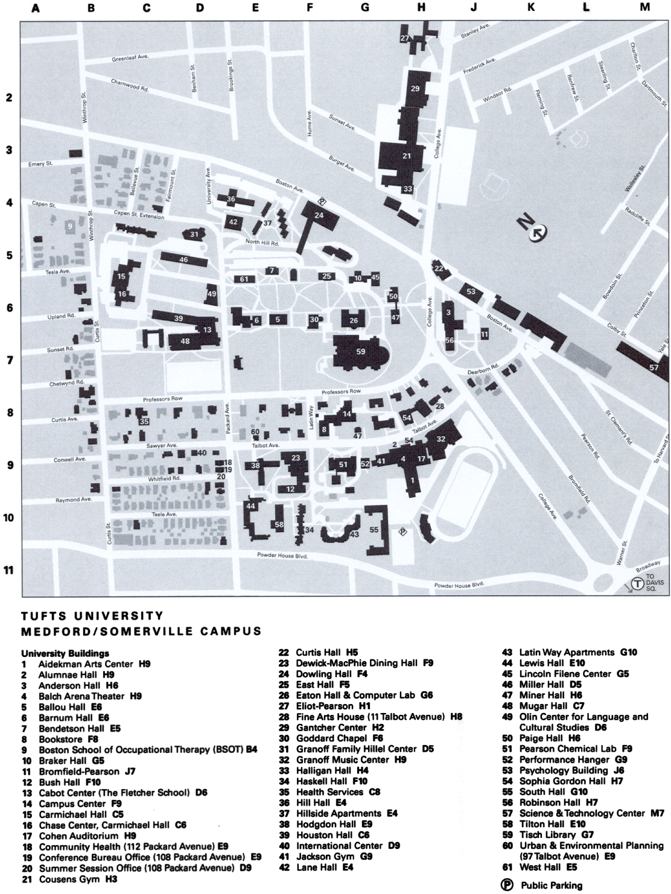

WEDDINGS AT
GODDARD CHAPEL
AND
THE INTERFAITH CENTER

TUFTS UNIVERSITY
MEDFORD, MASSACHUSETTS

(617) 627-3427



